Name: SHAHABAS K

Questions and Answers

1. Given an integer, , perform the following conditional actions:

* If  is odd, print Weird
* If  is even and in the inclusive range of  to , print Not Weird
* If  is even and in the inclusive range of  to , print Weird
* If  is even and greater than , print Not Weird

Code:

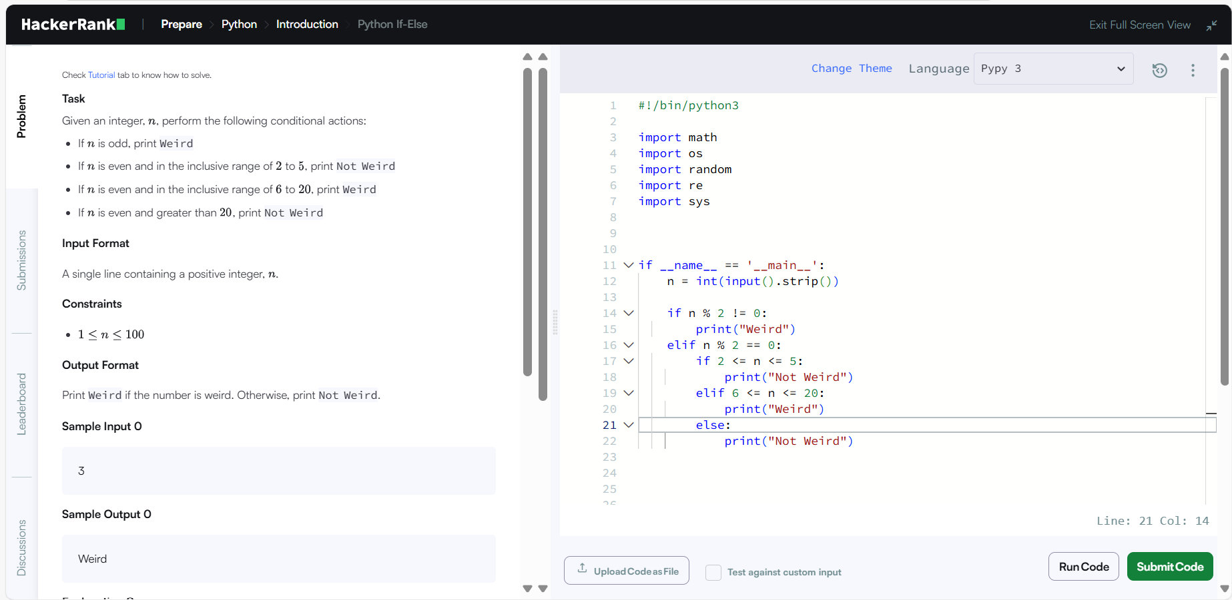

Output:

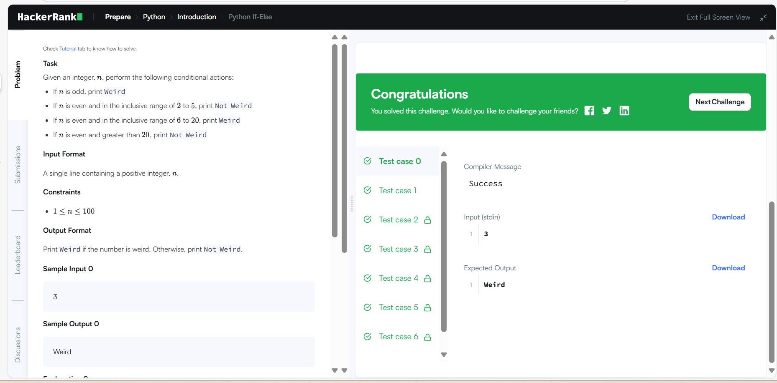

1. The provided code stub reads two integers from STDIN,  and . Add code to print three lines where:

* The first line contains the sum of the two numbers.
* The second line contains the difference of the two numbers (first - second).
* The third line contains the product of the two numbers.

Code:

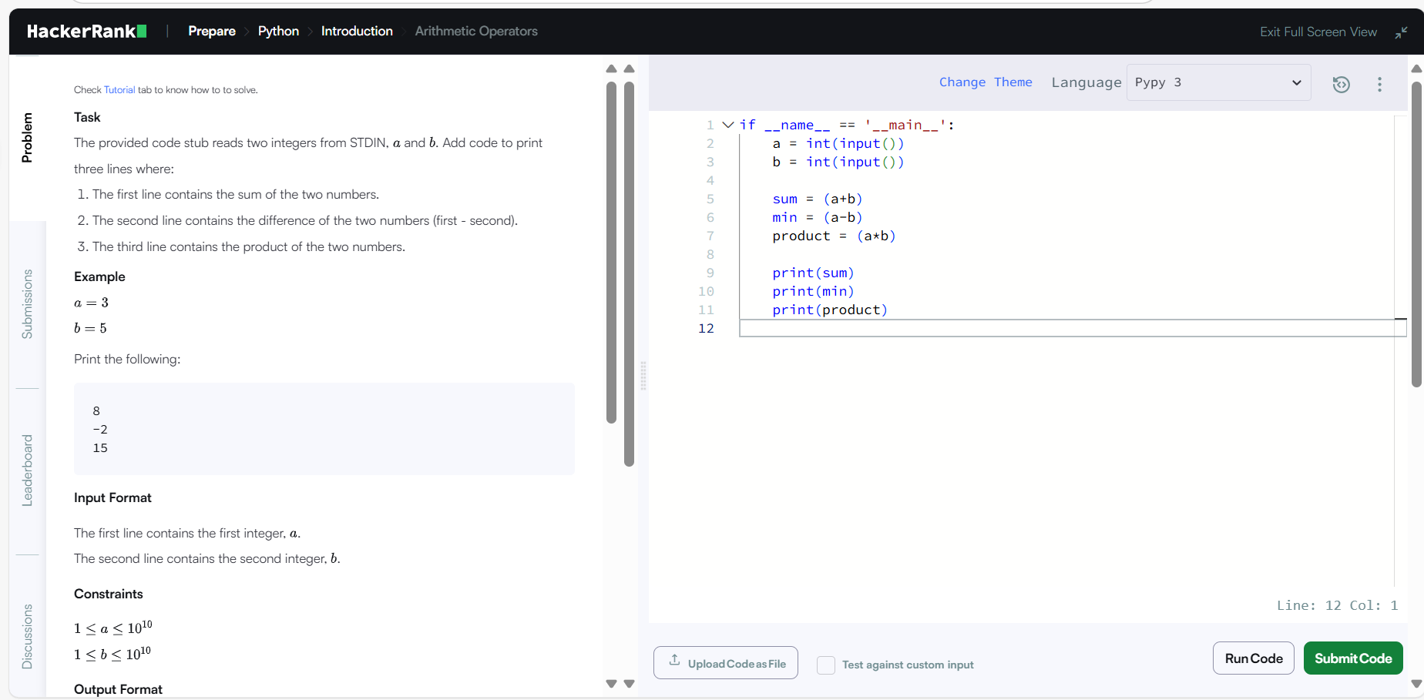

Output:

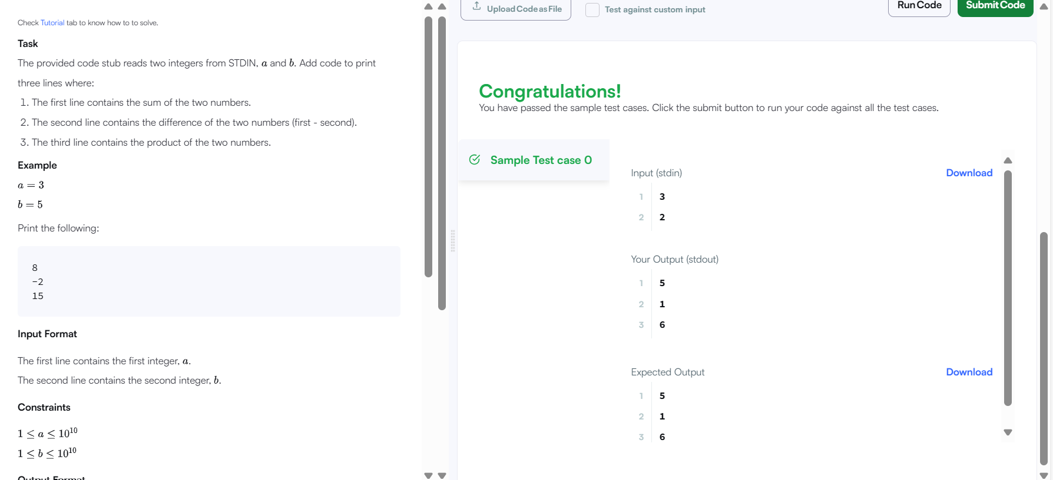

1. The provided code stub reads two integers,  and , from STDIN.

* Add logic to print two lines. The first line should contain the result of integer division,  // . The second line should contain the result of float division,  / .
* No rounding or formatting is necessary.

Code:

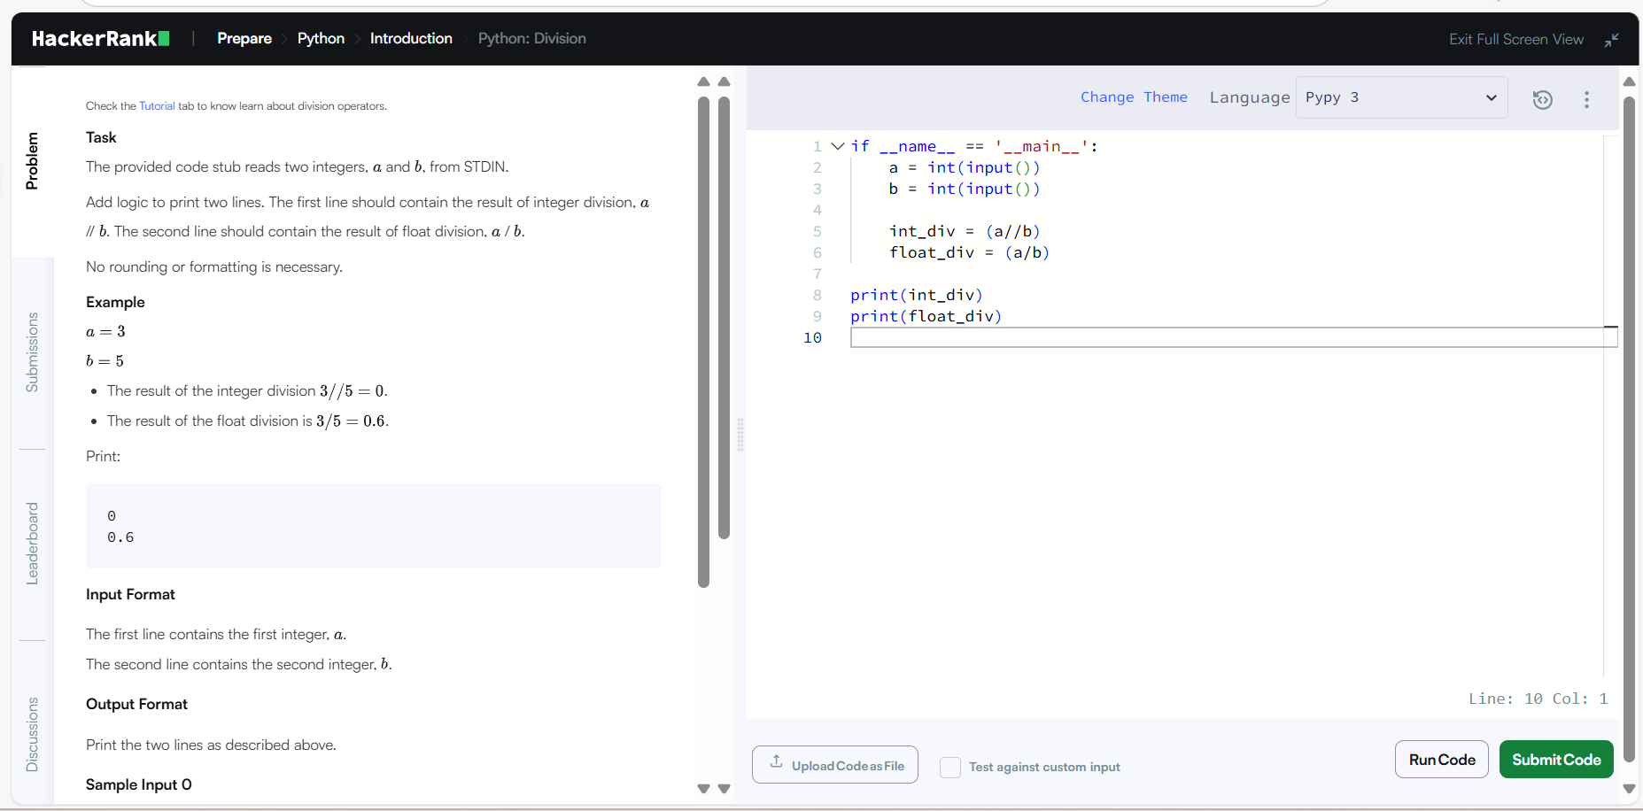

Output:

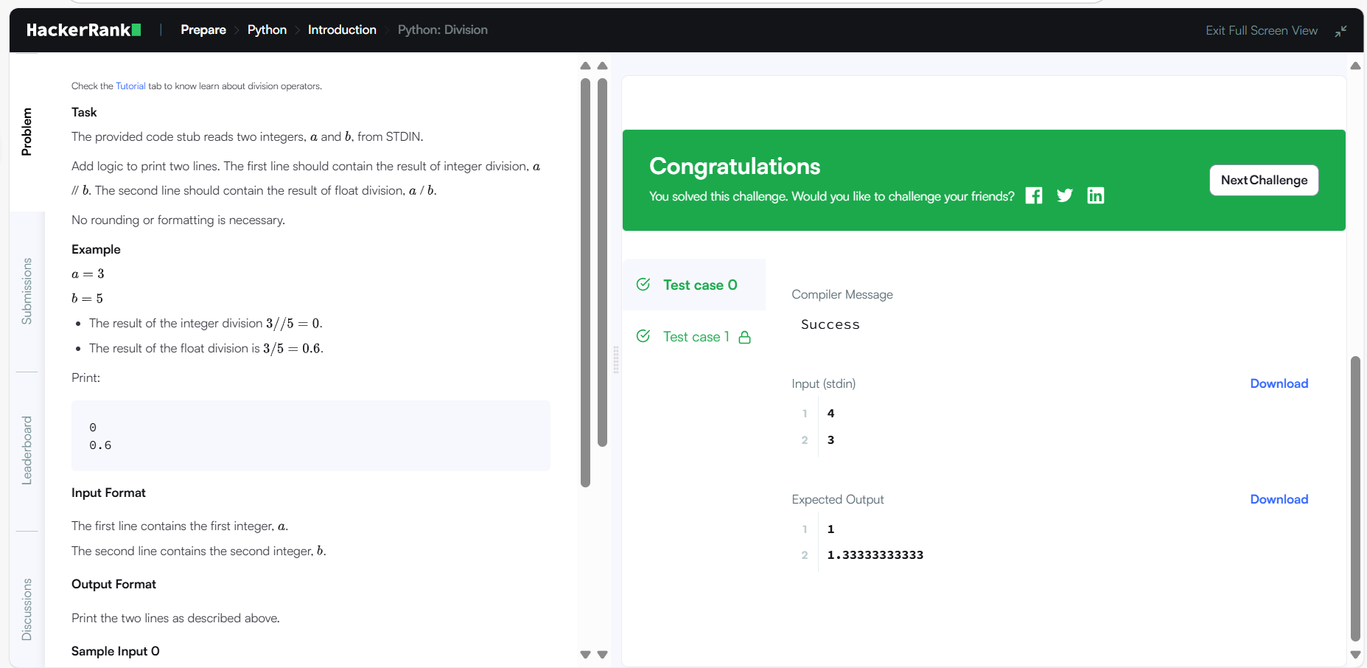

1. The included code stub will read an integer, , from STDIN.

Without using any string methods, try to print the following:

123…n

Note that "" represents the consecutive values in between.

Code:

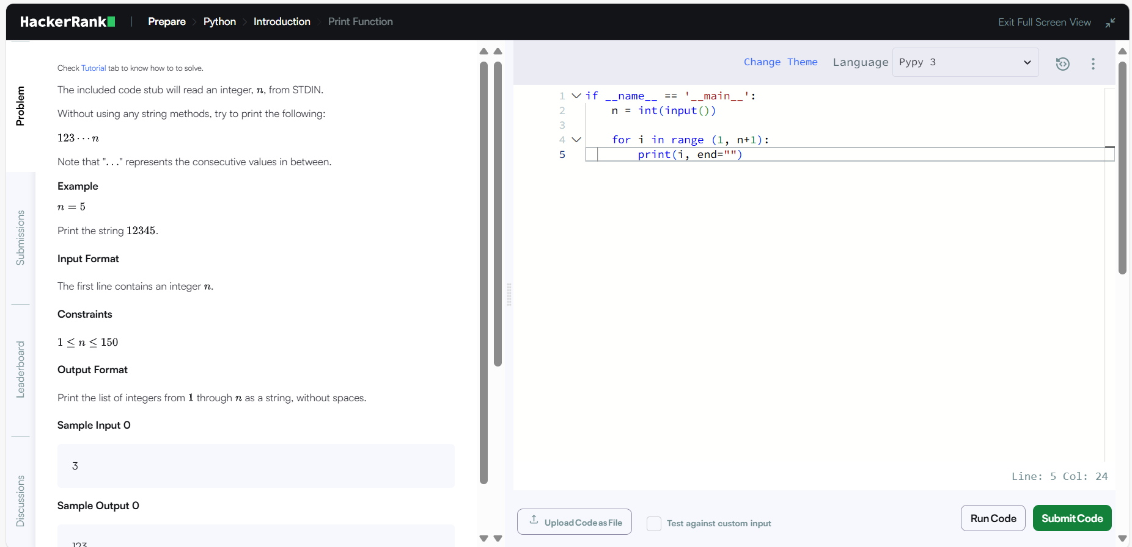

Output:

